Psychiatric Drug Cocktails:
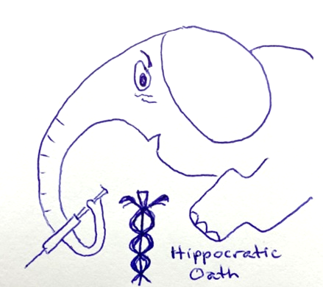
is fully-informed consent even possible?

(20250406, Deirdre Moore, BBA, CFA) Imagine you are a drug manufacturer, such as Johnson & Johnson¹ (“JNJ”), that has developed a new drug for its product pipeline; but, during trials all of its subjects died once the dosage reached 20 mg/day while at 10 mg/day they didn’t. All JNJ would need to do is seek FDA² approval for (and market) the lower dose. Right?
But, what if JNJ competitor Sandoz³ makes a similar drug and recommends a 10 mg/day maximum dose too?
Next, add a nurse practitioner⁴ and/or a psychiatrist⁵ who have the unbridled power to prescribe both⁶?
(TO DO: insert description of the problem created and insert sample combined risk profiles using manufacturers’ product monographs.)
“Combining so-called anti-psychotic⁷ agents circumvents FDA safeguards and creates totally different risk profiles of which the patient/guardian would likely be totally unaware.”
~ Andee Jak
On 20250329, I posed risk-profile questions to Internal Pharmacy⁸ at the Erie County Medical Center Corporation (“ECMCC”)⁹. Their response? “Don’t [contact] us again.”
If no one has studied how the risk profile of combined-drugging could impact the patient, then how could anyone ever provide the fully-informed consent that is required for all medical procedures?
#ECMCC #ForcedDrugTrials #Epidemiology #InsuranceCompanyFraud #HumanTrafficking

FOOTNOTES
¹ See preliminary analysis of JNJ’s so-called anti-psychotic agent INVEGA linked to https://twb.rocks/invega/product-monograph; and, realize that JNJ has spun out its “cash cow” products to a new brand “Kenvue”. ² that is, U.S.’s Food & Drug Administration ³ See allegations against Sandoz at https://twb.rocks/sandoz ^{4, 5} See #twbROCKS #KaraokeCover tunes “Even if I’m Shunned” and “Just a Pharma Whore” inspired by ECMCC’s Brenna Fox and Michael Guppenburger, respectively, at https://twb.rocks/mummygate/rolling-credits ⁶ See New York State’s Justice Paula L. Feroleto’s scandalous 20250402 court order at https://twb.rocks/domestic-terrorism/perpetrators/individuals/paula-feroleto
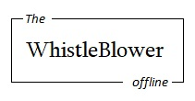
⁷ See etymology for psychosis (and, outline for “Transitioning into Sociopathy”) at https://twb.rocks/resources ⁸ See copy of 20250331 Court Submission #1, page 15.001 stored at https://twb.rocks/wp-content/uploads/2025/06/20250521-Letter-to-ECMCC-Quatroche-Exhibit-J.pdf ⁹ See evidence of Medicaid/Insurance Company Fraud linked to https://twb.rocks/living/exposure/ecmcc/thomas-quatroche.

