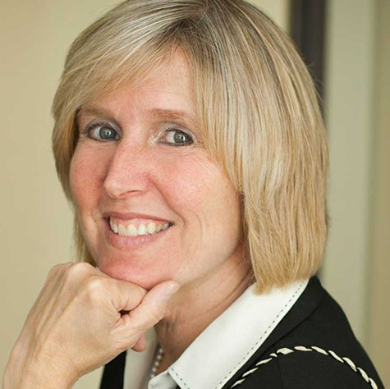
Are they all demonic¹?
It all started with
... Katie Laframboise ²
who wrote whatever Kiska ³ said
(breaking all sorts of laws).
Then, Victor Ages Vallance ⁴
“overlooked” their flaws:
a new divorce to be played out
(by their sick, greedy paws).

Are they all demonic? Can’t they think?

♫ (chorus)
It’s Bell Baker LLP
that enabled this crime:
at 116 Lisgar Street:
they’ll take your very last dime.
Their job’s to lie and steal and cheat
(they get paid for their time).
They’ve got nothing to fear
… with our Mayor ⁵.
Mr. Wade L. Smith ⁶,
a Bell Baker guy ⁷,
has zero conscience left
(and would tell any lie).
When he tried his very best
to be his absolute worst,
he forgot that it’s written
the last will finish first.

Are they all demonic? Can’t they think?

♫ (repeat chorus)

[bridge]
Well, Smith is retired now;
and, he could not care less:
as he lives off the millions that he made,
He’s simply a YOLO ⁸ hound.
Thinks he’s living life in the sun;
not knowing he’s in the shade.

Now it’s Cheryl Hess ⁹
(four years at the helm):
seems so clueless
of this Satanic realm.
She thinks it’s over now:
I lost my daughter and son.
She doesn’t realize,
… the end has only begun.

Are they all demonic? Can’t they think?
Is it not moronic, building ships to sink?

♫ (repeat chorus)

Well, He has a funny way
of sneaking up on you
And He had a funny, funny way
of helping me out, helping me out.

¹versus, Satanic? Or, just plain serpent seed à la Genesis 3:15? ²This woman’s defamatory libel kicked off FC-15-2446 before I could serve my Form 8A seeking a divorce for cruelty. ³Testimony/evidence for “The Real John Kiska” is being stored at https://twb.rocks/domestic-terrorism/perpetrators/individuals/john-kiska ⁴Now, Victor Ages Blais LLP ⁵See https://twb.rocks/domestic-terrorism/perpetrators/individuals/mark-sutcliffe ⁶Testimony/evidence linked to https://twb.rocks/domestic-terrorism/perpetrators/individuals/wade-smith ⁷vs.Charlotte Watson, a career-criminal Bell Baker gal ⁸ “You Only Live Once” myth ⁹ See https://twb.rocks/domestic-terrorism/perpetrators/individuals/cheryl-hess

