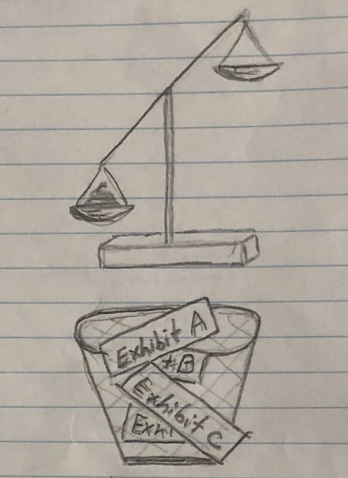
False-Positive Conviction
Verse 1
All the courts are raving ‘bout
False-Positive Conviction.
(Judge, Crown, lawyers go for that conviction.)

Avoid any changes that might
create some “friction” ¹.
(So says Downey ²: “must get that conviction”.)

It’s really easy when they’ve got
some cops on their side;
And exculpatory evidence
that’s easy to hide ³,

♫ So, c’mon, c’mon:
False-Positive Conviction with me.
Just have to wipe your hands and shrug:
“System’s broken. Not my fault … no one’s woken;
and, if not I, someone else would. So, anyhow …”
Verse 2
Lots of crooks can profit from
False-Positive Conviction.
(Judge, Crown, lawyer: please get that conviction.)

If they nail a tenant they can
force an eviction.
(Why steal? Just seek False-Positive Conviction ⁴.)

If they’ve got some children then
it’s worth even more:
The CAS ⁵ will traffic them
through any front door.

♫ So, c’mon, have fun:
False-Positive Conviction with me.
Just have to wipe your hands and shrug:
“It’s not my game … I don’t care … such a shame
[that I actually fund the whole thing].” Anyhow …

Verse 3
Now you know some moves of the
False-Positive Conviction.
(Judge, Crown, lawyers “paid” for each conviction. ⁶)

Can you see how “just” is just
a justice depiction:
one big racket, full of contradiction ⁷.

Do you have some thoughts on that
which we should do?
Replace it all with AI ⁸:
get the bar/bench removed?

♫ So, c’mon, be done:
end False-Positive Conviction with me.
Self-present ⁹ everyone and drain it [their supply]: without us? They’d all cry.
(Then, stop their coke and booty too! Coup!).
Anyhow.

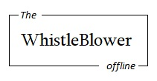
¹ See Crown’s modus operandi evidenced at https://twb.rocks/political-persecution/criminal-court ² Ontario’s smarmy Attorney General, Douglas Downey, as pictured at https://twb.rocks/mummygate ³ or shred ⁴ See introduction to organized stalking and harassment at https://twb.rocks/gang-stalking ⁵ ie. Children’s Aid Society of Ottawa: a taxpayer-funded, for-profit, criminal enterprise as evidenced at https://twb.rocks/domestic-terrorism/perpetrators/entities/cas ⁶ As sociopaths, they also enjoy the “sport” of it all: see recently-promoted-from-OCJ viper at https://twb.rocks/domestic-terrorism/perpetrators/individuals/maria-sirivar ⁷ See Canada’s Evidence Act’s “delete key” s. 37(6.1) and embrace the dark humour that is every sustained Crown objection to “relevance” as discussed at https://twb.rocks/living/opinion/relevance. 8 Musk et al.’s stated goal. More on Musk at https://twb.rocks/living/spirit/elon-musk_deirdre-moore ⁹ Self-REpresent … whom??

