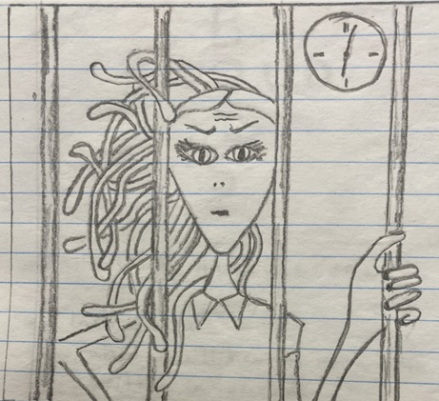
OCDC Count

Verse 1
She’ll count the inmates in the stall.
She’ll count the posters on the wall.
She’ll count “extensions” on a shelf;
but, most of all, she counts … herself.

♫ Just a jail guard, jail guard,
DFR loves counting:
1 – 2 – 3 – 4, 1 – 2 – 3 – 4.
How she loves to count.

Some say, one day,
(if she learns ‘bout rounding),
she’ll count all her hounding
make a plaque that she can mount

Verse 2

She’d count her cackles in the hall.
She’d count the seconds to “last call”.
She counts the minutes ‘til the nurse
in vain attempts to make … things worse.

♫ She’s a jail guard; not hard
to see her need for power—
every 30 minutes barking
that which we should do.

“Lights on!” “Greens don!”
Never mind the hour:
She loves being sour
Just as all narci … ssists do.

Verse 3

As people swap for silver/gold
(aware of fiat growing old),
instead of saving for the “turn” ¹
she fuels her own eter … nal burn.

♫ Simple jail guard (safe, barred),
DFR should transfer
herself off to Laval ² where the
sadists all have fun.

Maybe, she’d see—
with so many minions—
some have the opinion
Revelation nine … teen’s done ³.

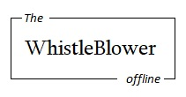
¹ The impact of the international transition to digital currency should not be under-estimated. For an introduction to that and more, see https://twb.rocks/living/opinion/agenda-21. ² My experience at Leclerc Laval (i.e. Laval Prison in Quebec, Canada) in March-April 2019 revealed personalities and systems that I had never before experienced and would never have believed existed if not for my own eyes and ears. Some testimony and evidence is stored at https://twb.rocks/domestic-terrorism/perpetrators/entities/leclerc-laval. ³ In other words, we are already in Revelation 20 of the Biblical timeline; specifically, Revelation 20:7-10 in Satan's Little Season as described at https://twb.rocks/living/spirit/satans-little-season.

