Just a Pharisee^{1, 2}

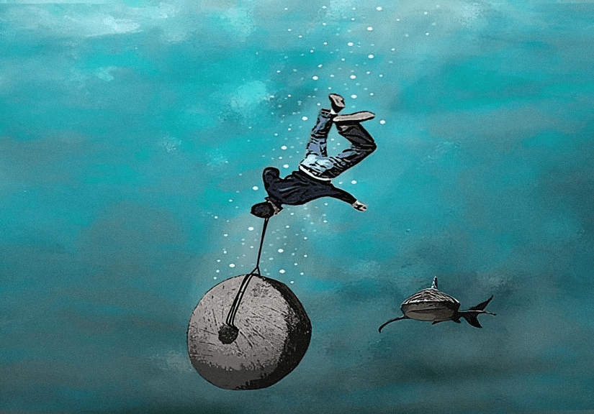

Verse 1
I’m just a Pharisee: I care for only me.
Really like the part I’m playin’.
Nothing’s up to chance,
wearing robes (not pants),
Ooooh, I love slayin’.

Sure there’s some that say:
“one day I will pay”
Meh, if so I plead a dim-wit.
When the End comes, I was told,
that I’d get all the gold
Aaaand, I bought it.

♫ (chorus)

‘Cause,
I believed my Rabbi.
He said we, were guilt free,
could screw thee, merrily.

I don’t even know why
Just feels right, so black-white
With snake bite, I’ve no fright.
Verse 2
I’m just a Pharisee & Matthew 23
Really don’t mean nothin’ to me.
Sure I see the words,
I think that they’re absurd
Have no ears/no eyes:
can’t hear/see.

If there comes a day & trouble comes my way
Do bee, do bee
I’ll just repent and you’ll see
Luke 17 verse 2, was not meant for me
(just you)
‘Annnd, god loves me.

♫ (chorus)

‘Cause,
I believed my Rabbi.
He said we, were guilt free,
could screw thee, merrily.

I don’t even know why
Just feels right, so black-white
With snake bite, I’ve no fright.

¹ Meant to be sung “A Capella” (that is, without music) and will only take about 01:45. ² These lyrics are dedicated to all of the lawyers and judiciary officials responsible for ripping my children, Sean & Cate, from my life as evidenced at https://twb.rocks/political-persecution/family-court; but, especially:
- Gonen Snir and
- Joe Addelman
as described at https://twb.rocks/domestic-terrorism/perpetrators/individuals/two-shysters.


