Not A Movie
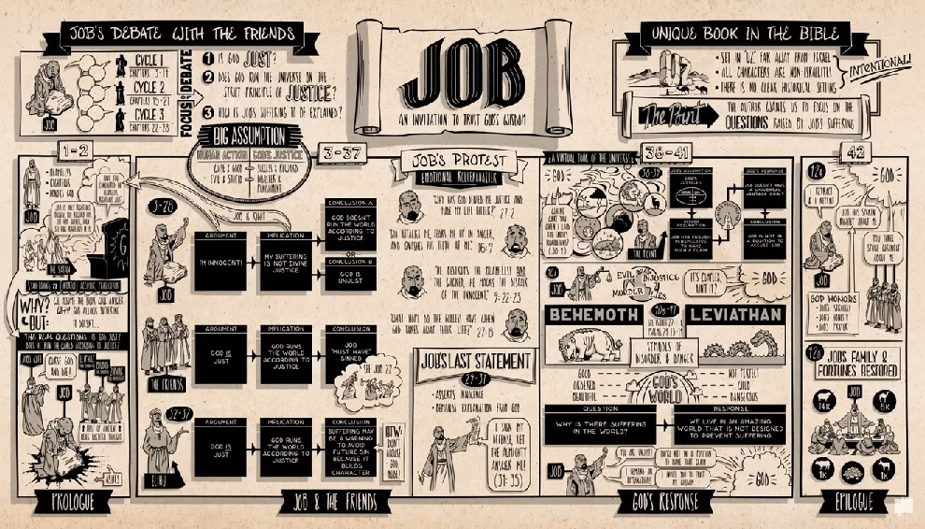
Screenshot from “Book of Job Summary: A Complete Animated Overview” by BibleProject.com
Verse 1
Don’t frown at the next broadcast¹.
Don’t be programmed² like the masses.
Know their stories have a reason³.
Yes it’s scripted; but, not a movie.

♫ It’s all scripted; but, it’s
not a movie.

Verse 2
What has he grossed, with his lyin’⁴?
Knows he’s beat⁵ but he’s still tryin’⁶.
It’s clear we’re in his little season⁷
(while people watch saying “Just a movie”).

♫ Yep, there’s lots of bad actors⁸; but …
not a movie.

Verse 3
Job held his conviction despite his grief⁹:
Not his wife nor his friends could rock his belief.
While it’s tempting to question His goals for the meek¹⁰,
know for one thing: not a movie.

♫ Bad ad, a bad ad, bad ad (not a movie)
♫ Bad ad, a bad ad, bad ad (not a movie)
♫ Bad ad, a bad ad, bad ad (not a movie)
♫ Bad ad, a bad ad, bad ad (not a movie)
♫ Bad ad, a bad ad, bad ad—feelin’ groovy.

For this (and more reality-based #KaraokeCover tunes), see https://twb.rocks/mummygate/rolling-credits

¹ The etymology of “broadcast” includes disseminate (ie. propagate widely, plant seeds extensively) ² That is, indoctrinated (as explained by a 6-minute animated summary of Dietrich Bonhoeffer’s “Theory of Stupidity” available at https://youtu.be/ww47bR86wSc) ³ That is, purpose (like all propaganda: see example preceding 20251010 post at https://x.com/CaeJak/status/1976762384451797416 ⁴ Satan is the father of lies: see John 6:44 ⁵ As prophesied in Book of Revelation 20:7-10 ⁶ Satan even propositioned His Son! See Matthew 4:1-11, Mark 1:12-13 and Luke 4:1-13
⁷ That is, Satan’s little season (see work-in-progress information hub at https://twb.rocks/living/spirit/satans-little-season ⁸ See Altiyan Childs’ 5-hour video exposé on the entertainment industry at https://youtu.be/jxRoSTak_0I ⁹ See BibleProject.com’s 11-minute animated summary of the “Book of Job Summary: A Complete Animated Overview” at https://youtu.be/xQwnH8th_fs. Disclaimer: Despite its obvious short-comings including, but not limited to, the fact that it completely ignores the truth contained in Genesis 1:1-31, this summary serves as a useful introduction to His Old Testament book. ¹⁰ Fun fact: one acronym for Elon Reeve Musk is “Never Meek Soul” (see draft outline at https://twb.rocks/living/spirit/elon-musk).

