Dear Dr. White,
Re: More TMR product suggestions + Warning about New York State & more*
I am hoping you will consider adding “non-liquified soap” to your Third Man Records (“TMR”) product offerings.[1] Why? I think that the entire industry is positively ridiculous for multiple reasons [2]. Enclosed are several samples for shampoo/conditioner and soaps that I found while in Tampa, Florida and Isla Verde, Puerto Rico.[3]
Another idea, “Meaningful Quest” (see work-in-progress prototype at images 001-003)[4]), could be a fun way to ramp Biblical literacy[5]. I was hoping to have the prototype in the mail to you by now; but, this project remains delayed.[6]
The “Chronology Canvas” (see work-in-progress prototype at image 013) could help people to better remember our history/Biblical past and be in a better position to put today’s events in context.
Currently preparing to cruise:
- to Fort Lauderdale, Florida
- from San Juan, Puerto Rico
- boarding on Friday, May 1, 2026 between 2:00 – 2:30 p.m. and
- disembarking on Friday, May 8, 2026 at 7:30 a.m.
- with scheduled stops in:
there was no option for a single ticket; so, I booked you in as my guest (see enclosed copy of reservation[7]), in case you have the opportunity and would like to discuss these initiatives in person.
In addition, I would like to share more American “imagery” since that which I provided from San Diego on March 16, 2026[8]. Enclosed are postcards from El Paso TX, Memphis TN and Tampa, FL; but, more imagery is being stored at https://twb.rocks/living/spirit/satans-little-season/cities. That “Raymond James” is prominently displayed in a not-symmetrical photograph of Tampa’s stadium (see image 015) was interesting to me because “Raymond James” was also prominent in Memphis, where the Satanic imagery was overwhelming (see images 016-018). That Revelation verse 20:11 may have been plucked from 20:9 (so that people would not realize that even Legion[9] abandons Satan before the fire) is not beyond the realms of possibility. That Legion’s new name may be James? Equally possible[10]: I have tons of photos that I intend to upload in a more organized fashion so Americans who haven’t been in a position to review this evidence for themselves might be inspired to find some time to investigate. Given my TI status, however, I am not sure when I will be able to complete this task.
I have also learned that Elon Musk’s ambitious “AI” (that is, Artificial Intelligence[11] ) plans require a lot of clean water[12] and believe his so-called “data centers” may have already gone vertical (see draft article outline stored at https://twb.rocks/living/exposure/vertical-AI and images 019-021 re: “photo-bombing” monstrosity in Chicago) with testing for some [cooling loop] possibly being done in Nashville (see collection of information about Elon Musk being stored at https://twb.rocks/living/spirit/elon-musk_deirdre-moore).
Finally, enclosed is draft article “Hug a Satanist Day!” which is being edited at https://twb.rocks/living/spirit/hug-a-satanist. It gets pretty dark, pretty fast; but, unlike Psalms 83:17―when some prayed for those who oppose God to perish―given the severity of Satan’s deceptions during his “little season” (see Revelation 20:7-10), I believe praying for their salvation better reflects Saint James’ (and others’) advice.
Verily,

Deirdre Moore, CFA, BBA
(518) 360-7003
Enclosures: /Kit-Sch/ Shampoo bar and Conditioner bar, Dr. Squatch Natural Soap, PACHA soap (all not yet vetted); Postcards―El Paso x 1, Memphis x 1, Chicago x 0 (see images 022-027)
PS. If you’re ever injured in Buffalo, New York, please stay far, far, far away from its alleged medical services.[13]
PPS. This letter started being pre-published on 20260421 at https://twb.rocks/living/appreciation/artists/jack-white/loving-jack-white/20260425jw in order to start sharing these draft ideas/exposés as quickly as possible. Given where I believe we are in the Biblical timeline (ie. near the end of Revelation 20:9), I felt that brain-storming solutions and exposing current realities was important … if not urgent. For this reason, this letter has also been circulated amongst an unknown number of politicians, corporate executives and social media pundits (see https://twb.rocks/domestic-terrorism/perpetrators/entities/erie-county-medical-center/ecmc_statement-of-claim) for multiple altruistic purposes.
**Bonus material added to this html version after 20260425 letter was sent: 20260511 18:50 > images 028-030; 20260512 by 09:00 > image 031; 20260512 09:55 The Parasitic-Predator Pawn Hierarchy at image 32;

FOOTNOTES
[1] As published at https://thirdmanrecords.com
[2] See draft article outline at https://twb.rocks/living/exposure/liquified-soap
[3] I have not had the opportunity to fully vet these products or their packaging.
[4] See up-to-date notes published as time permits at https://twb.rocks/living/spirit/meaningful-quest
[5] Another solution that I am currently developing is “Bible Bingo”: see images at 004-012 with updaates being published at https://twb.rocks/living/spirit/bible-bingo.
[6] A targeted individual (“TI”) subject to continuous “gang-stalking” (see introduction to this swarming/harassment network at https://twb.rocks/gang-stalking), I am prevented from being efficient at anything including, but not limited to, drafting “Unbridled Power & Insatiable Greed”―an evidence-based book series that will expose industry in Canada (and one to which you have the right of first refusal to publish (see https://twb.rocks/upig).
[7] You can check in, complete the 20260430 health report (mandatory) and obtain your luggage tags by creating a guest account on the Royal Caribbean website and selecting cruise reservation #4953925. (Note: given the “Muster Code” is F18, you can assume there will be gang-stalking units on this boat. See other reservation decodes at https://twb.rocks/hostiles).
[8] Hopefully you received my 20260316 package re: Sedona & the Grand Canyon (see image 014).
[9] See Saint Luke’s chapter 8 verse 30 re: our need to learn demon’s name knowing Saint Matthew’s 17:21 explained one reason for prayer and fasting.
[10] Photography while at the Central Station Memphis and excerpts from movie “High Fidelity” re: “It’s called James” to be uploaded to https://twb.rocks/living/spirit/satans-little-season/cities when time and WiFi access permits.
[11] Not to be confused with the “Artificial Omniscience” that Satan so desperately craves (see opinions at https://twb.rocks/living/opinion/transgenderism)
[12] See https://twb.rocks/living/spirit/satans-little-season/beast-system/fresh-water
[13] Exposure of Erie County Medical Center Corporation, multiple lawyers, multiple doctors and nurses; and, two “Supreme” Court judges is stored at https://twb.rocks/living/exposure/ecmc (along with a link to the html version of this letter for reasons already stated on page 2). Note that its CEO Thomas Quatroche (see specific evidence-linked testimony at https://twb.rocks/living/exposure/ecmcc/thomas-quatroche), has recently been given a huge promotion and chosen for a state-wide position: the president and CEO of the Healthcare Association of New York State. Maybe just avoid getting injured in that state?

IMAGES
001 – “Meaningful Quest” prototype | 002 – Title | 003 – Title
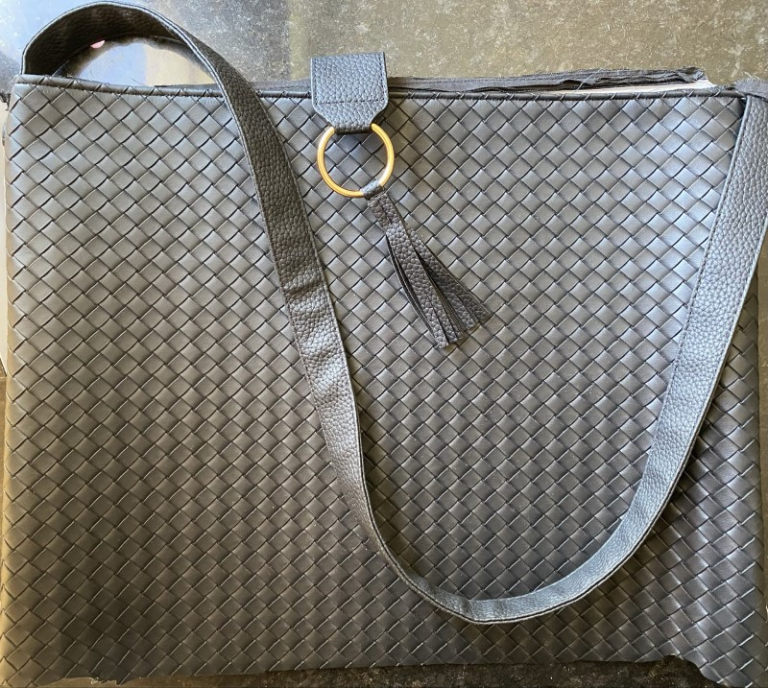 | 

002 – “Meaningful Quest” protype contents as of 20260326
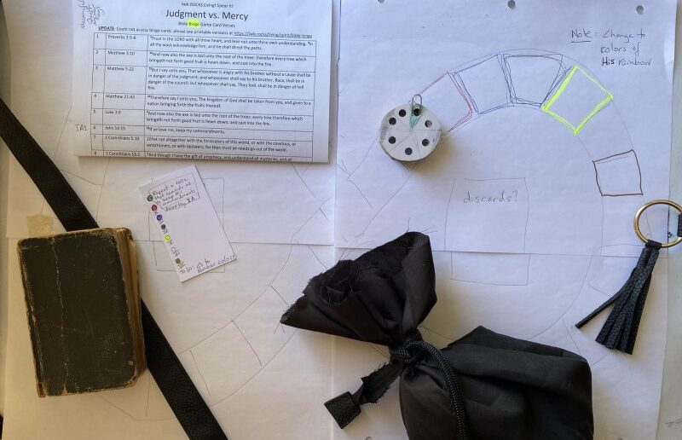
003 – “Meaningful Quest” protype contents as of 20260418
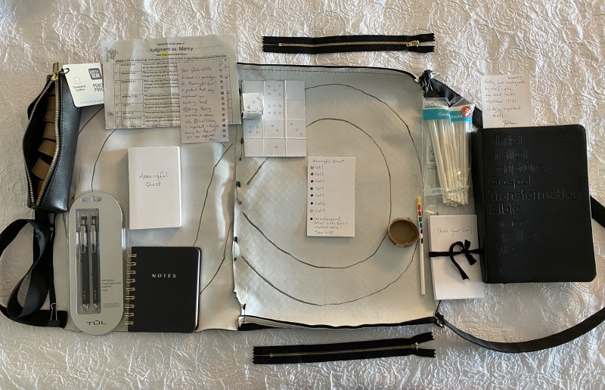

004 – Bible Bingo: Demon Casting sample verse selection – NOT YET VETTED!
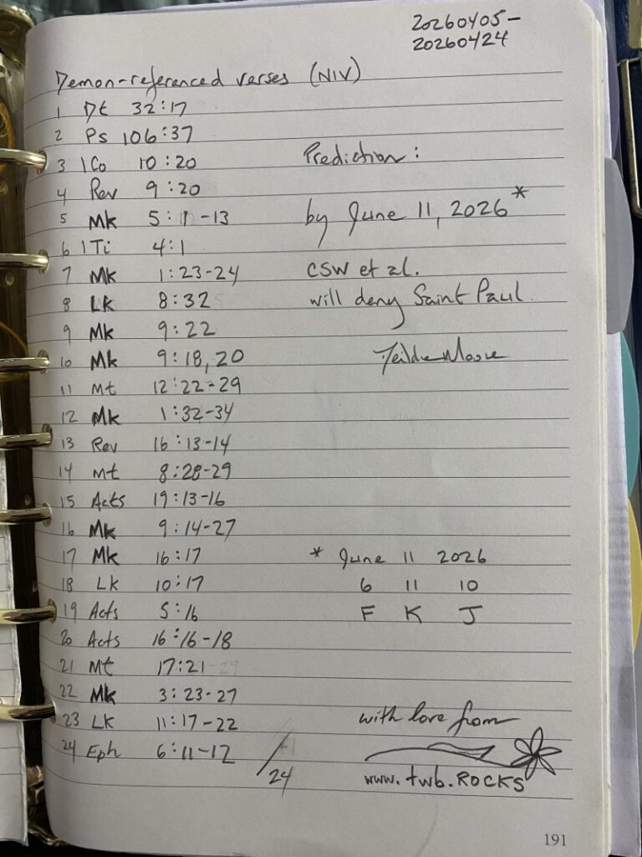
005 – Bible Bingo: draft Demon Casting verses (page 1)
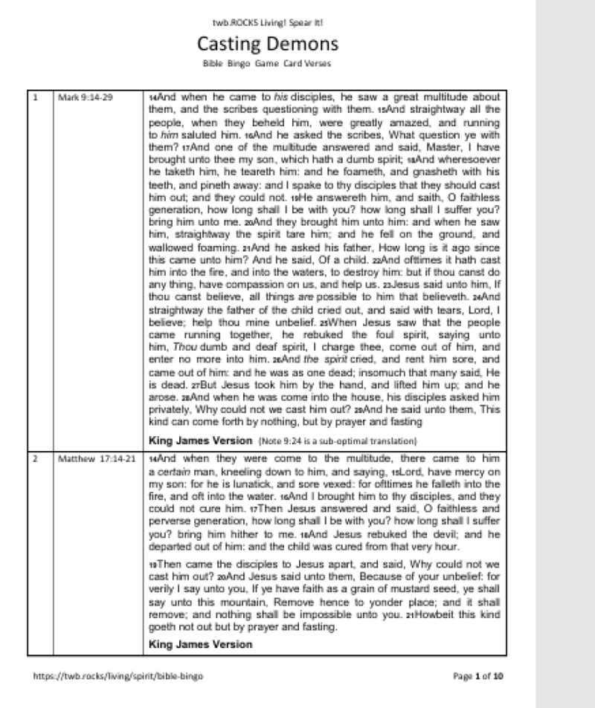
006 – Bible Bingo: draft Demon Casting verses (page 2)
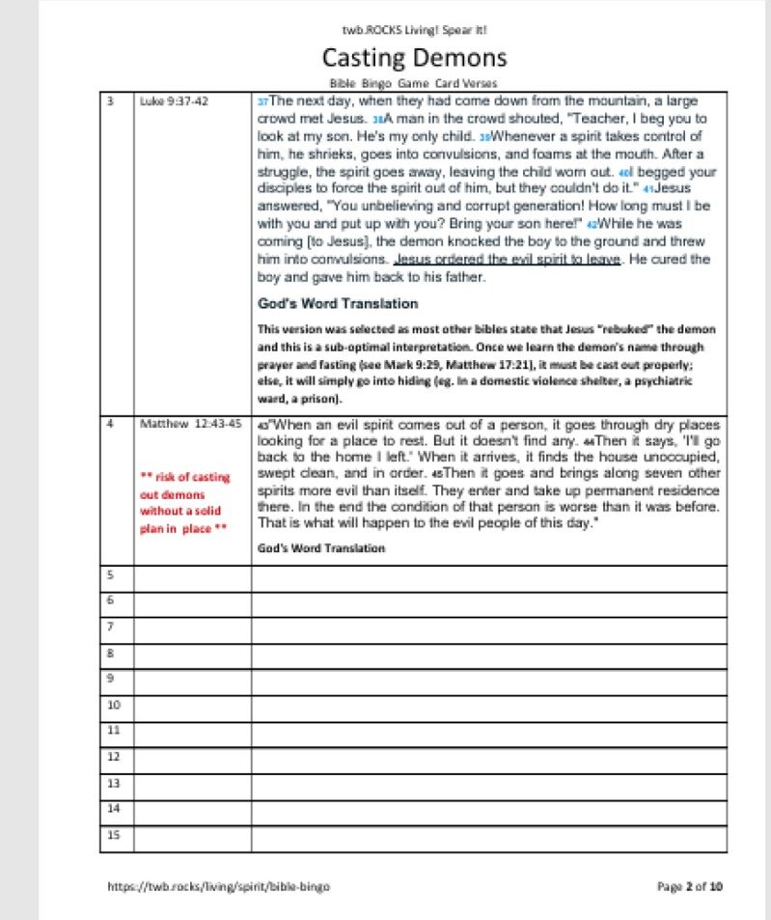

007 – Bible Bingo: Judgement vs. Mercy sample verses 1 – 14 (page 1)
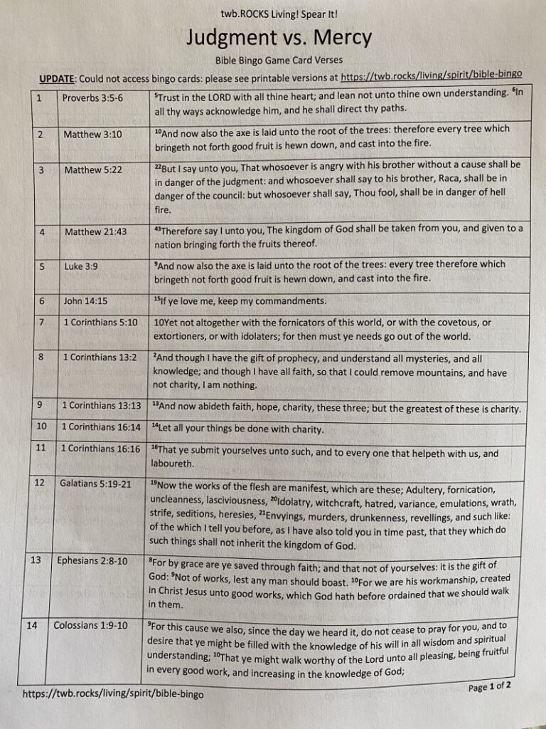
008 – Judgement vs. Mercy sample verses 15 – 24 (page 2)
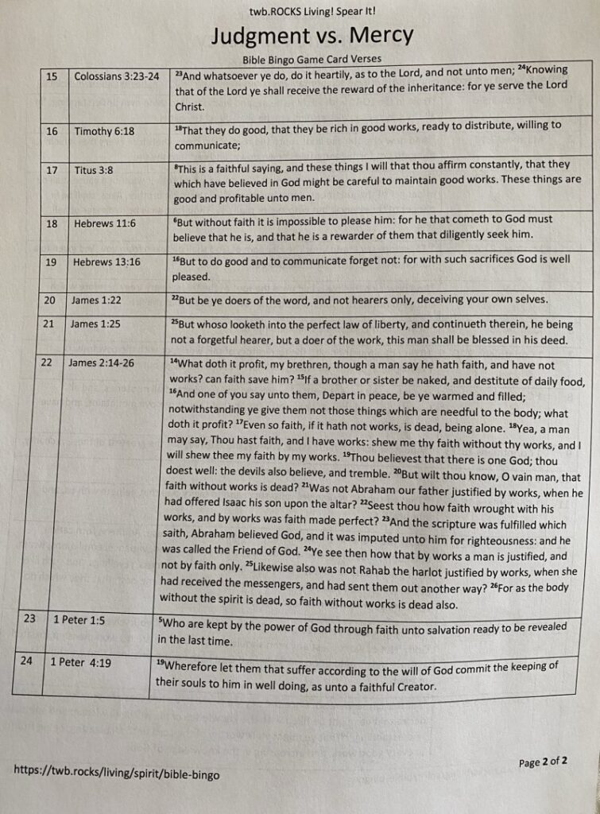
009 – Judgement vs. Mercy sample card
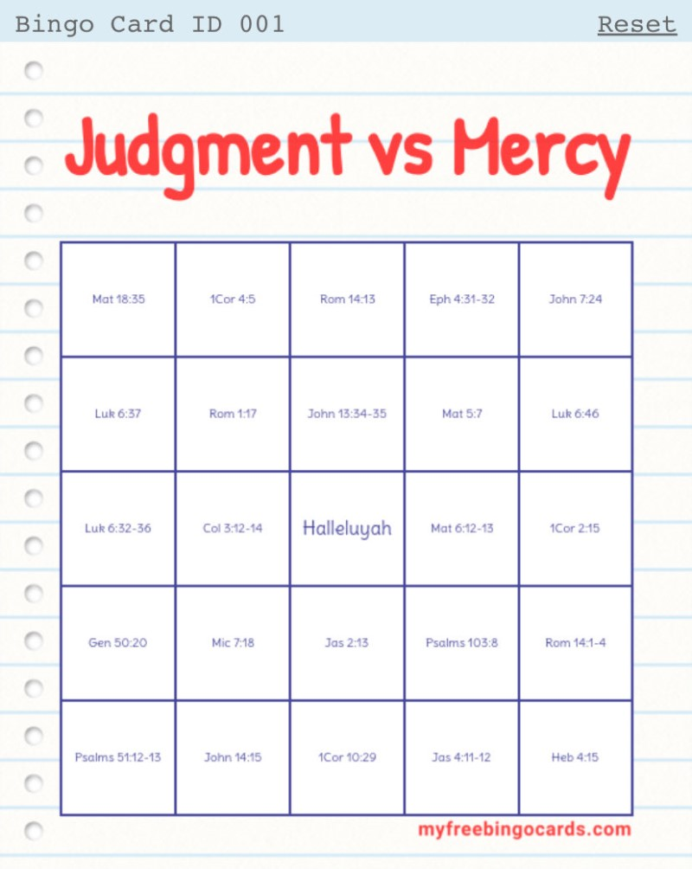

010 – Bible Bingo: Faith vs. Works sample verses 1 – 14 (page 1)
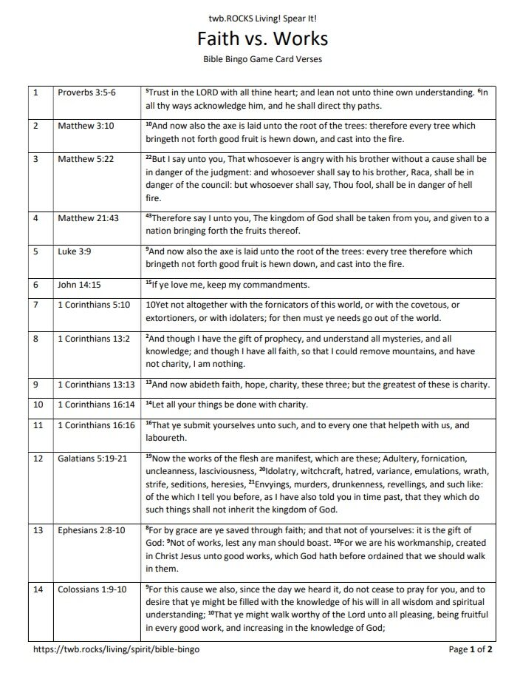
011 – Faith vs. Works sample verses 15 – 24 (page 2)
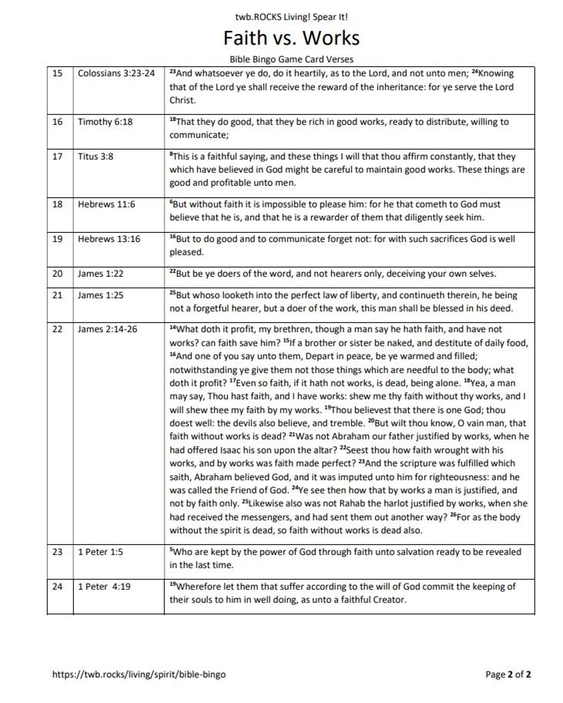
012 – Faith vs. Works sample card
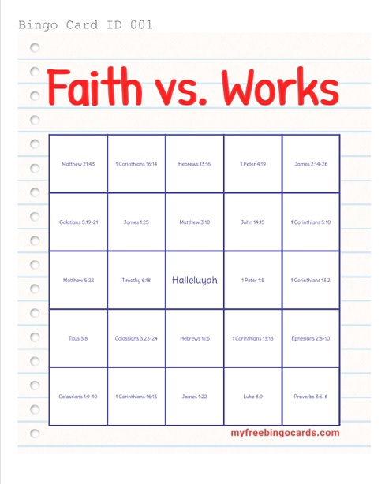

013 – “The Chronology Canvas”
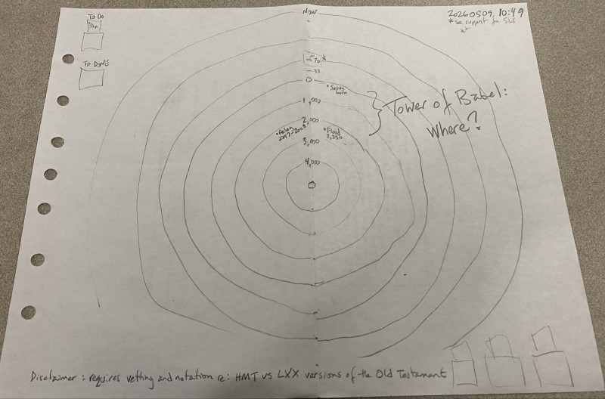
The hope is to produce a 3′ x 3′ (ish) canvas that would plot key Biblical events, people and prophets on a circular diagram with Genesis 1 at the center and Satan’s “little season” (Rev 20:7-10) along the outer ring. Whether or not events of the past 956.5 years are also plotted has yet to be determined.
Before I can start this project, I need to obtain a copy of the Septuagint (LXX) as it has been suggested ~650 years was removed from the OT’s Biblical timeline by the scribes who produced the Hebrew Masoretic Texts upon which most of our modern Bibles are based (see 32-minute video and other material linked to https://twb.rocks/living/spirit/chronology-canvas.
014 – 20260316 Parcel re: Grand Canyon and Sedona couriered from San Diego
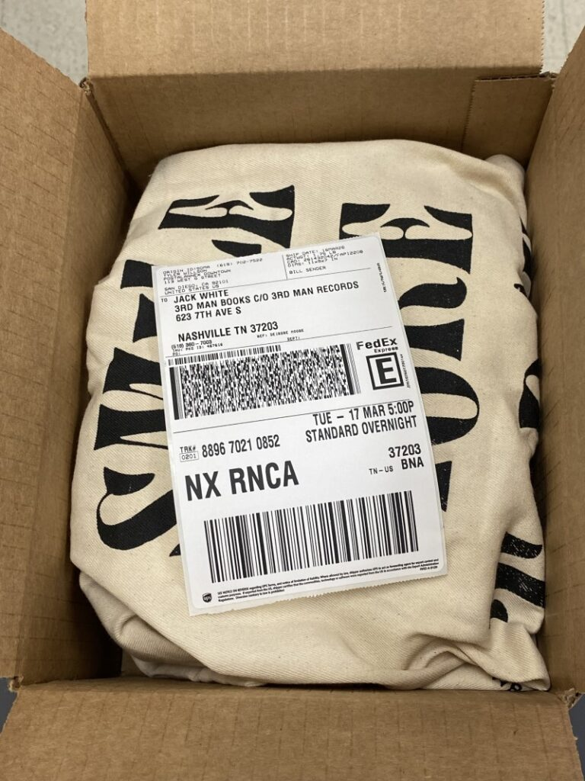
015 – “Raymond James and the Tampa Stadium”, a post card
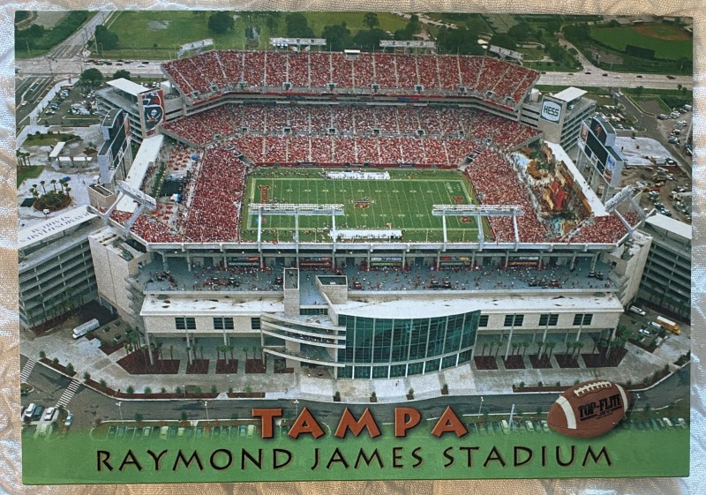
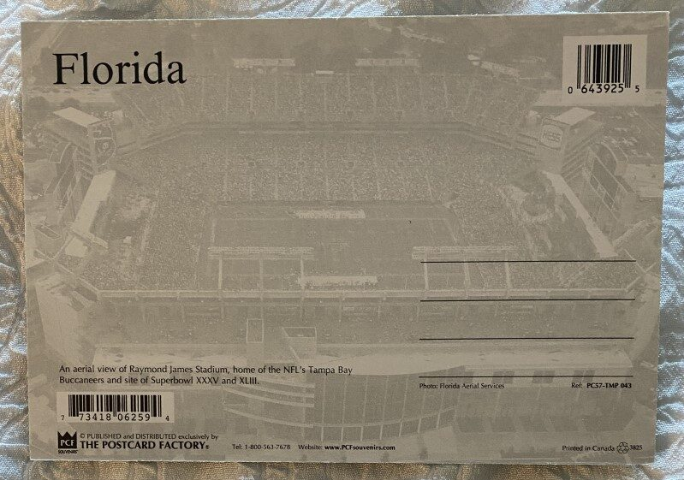

016 Memphis, Tennessee – “Jesus Fish” view to the right – Raymnd James
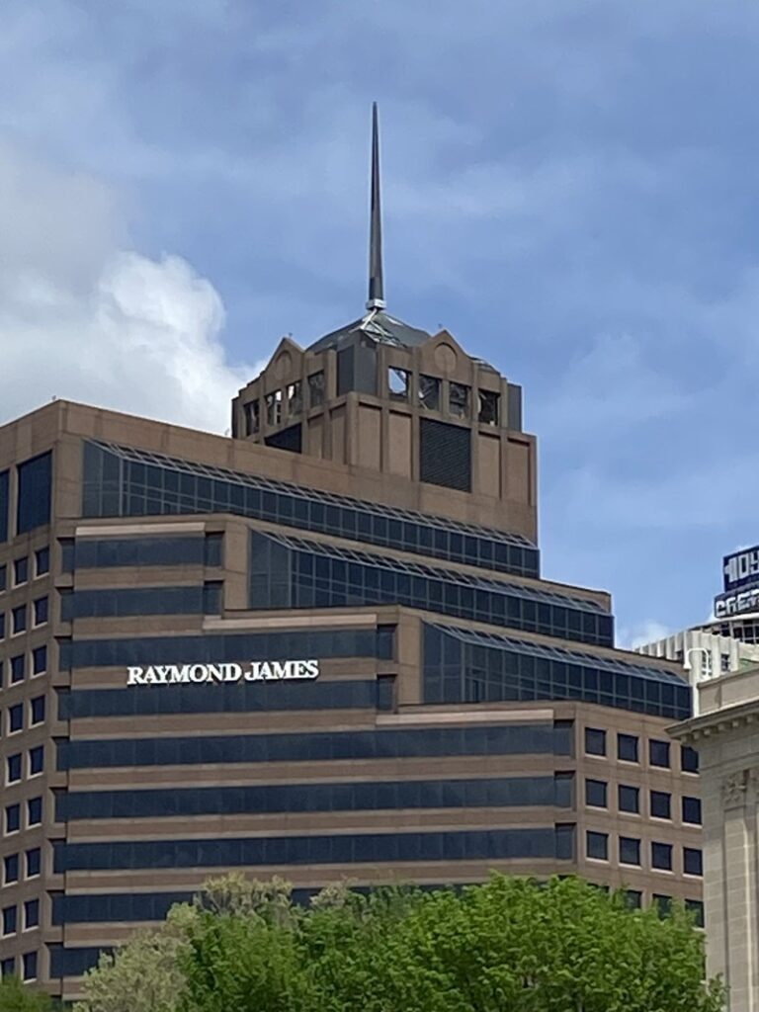
One anagram for Memphis, Tennessee is “Eminent mess Sheep”: another is “Sheep mess Eminent”
Side Note: An image search for Raymond James in Raleigh, North Carolina produced a building with a similar ?spear tip?:

017a Memphis, Tennessee – “Jesus Fish” view straight ahead – Point

017b Memphis, Tennessee – “Jesus Fish” view straight ahead – Curves

017c Memphis, Tennessee – “Curves + Point”

back of post card can be viewed at https://twb.rocks/wp-content/uploads/2026/05/20260418-Memphis-Tennessee-post-card-01.2.jpg
18a The Central Station Memphis – High Fidelity Lounge 01

018b The Central Station Memphis – High Fidelity Lounge 01

More imagery from Memphis, Tennessee is being stored at https://twb.rocks/living/spirit/satans-little-season/cities

019 – Image to be moved to article re: Non-Liquified Soap

020 – Image to be moved to article re: Non-Liquified Soap

021a – Image to be moved to article re: Non-Liquified Soap


021b – Image to be moved to article re: Non-Liquified Soap

021c – Image to be moved to article re: Non-Liquified Soap

021d – Image to be moved to article re: Non-Liquified Soap


022 – insert photograph
023 – insert photograph
024 – insert photograph

025
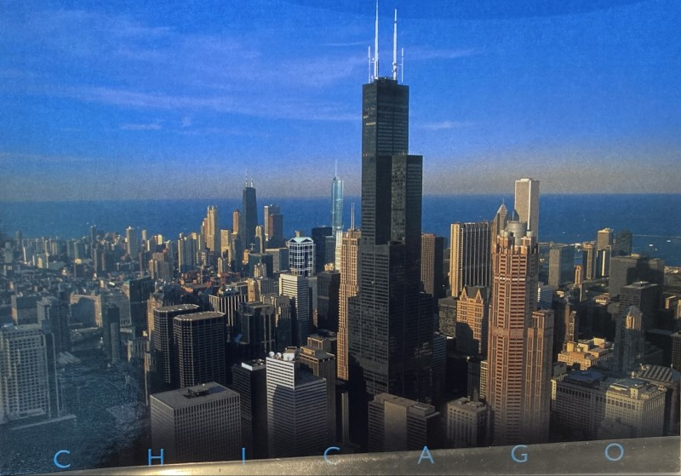
026
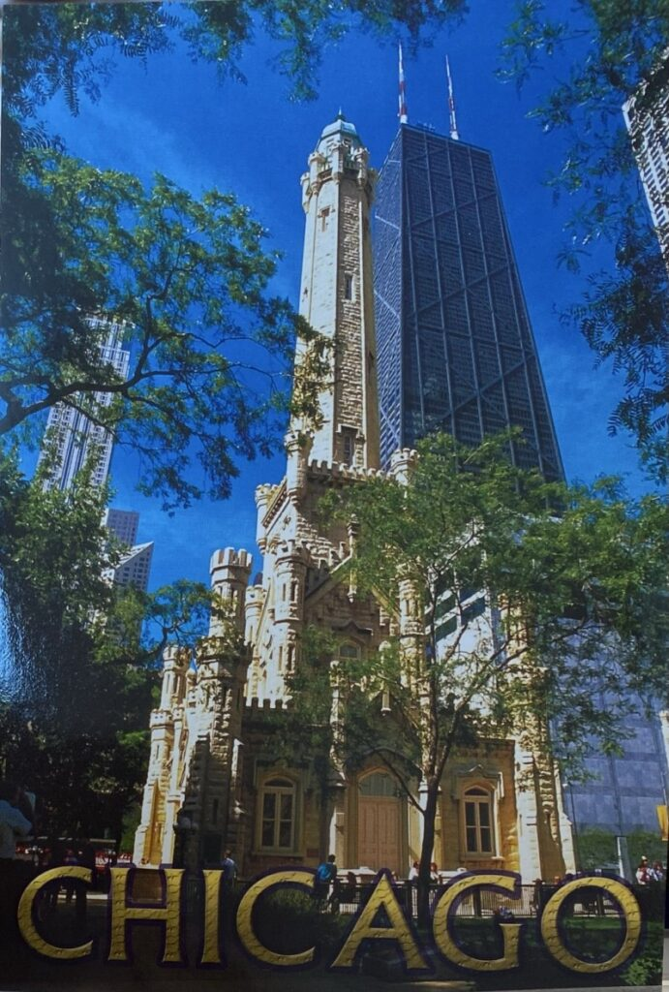
027
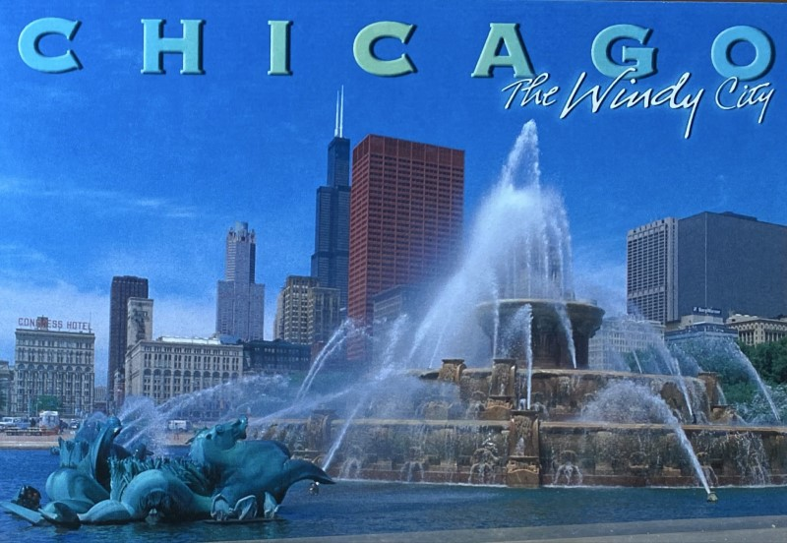

BONUS MATERIAL
028 – Insert title
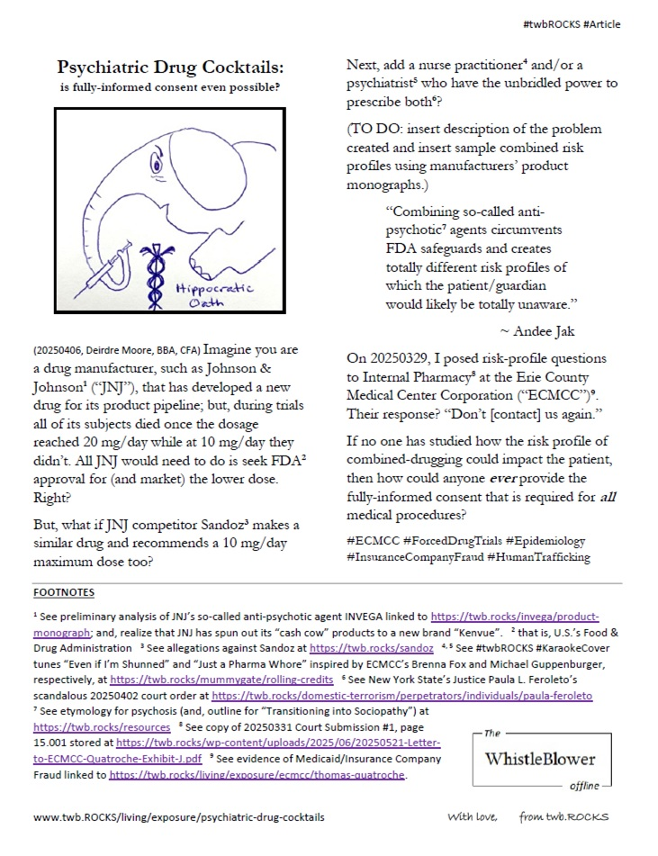
029 – Insert title
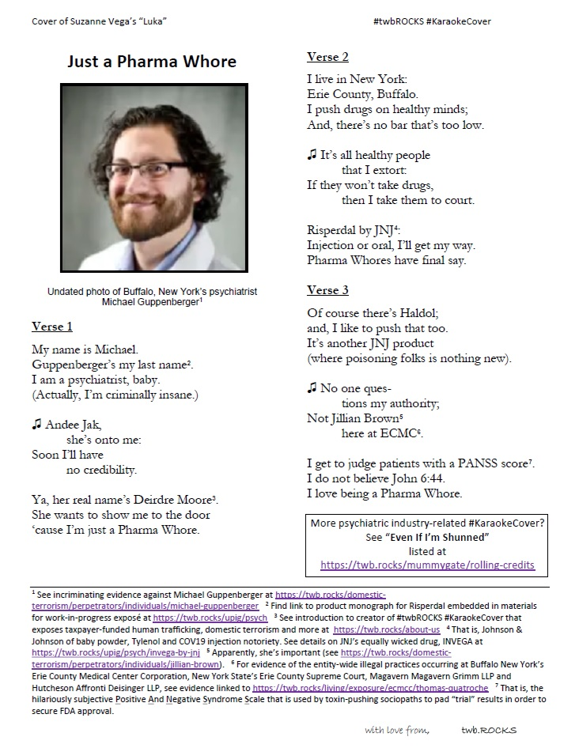
030 – Insert title
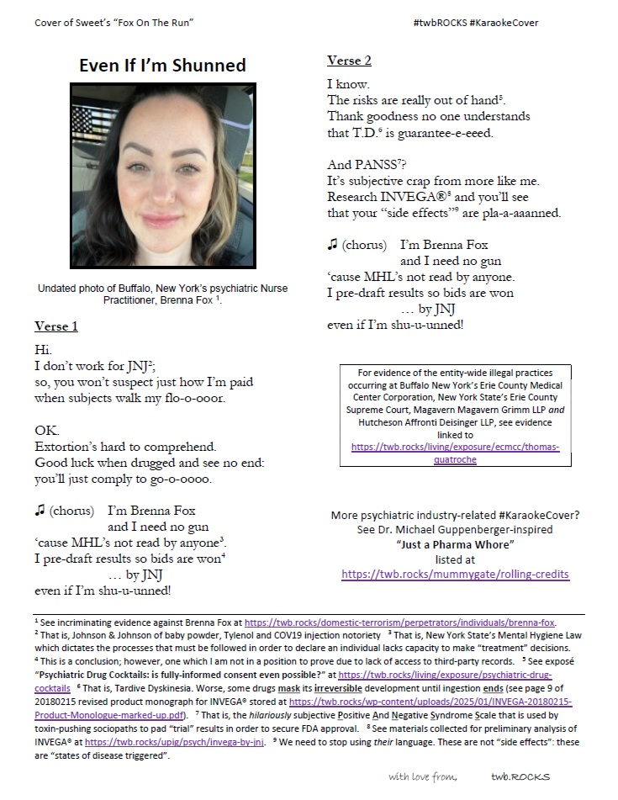
031 – Insert title

See more “New York Speculation” with 2020-2026 imagery stored at https://twb.rocks/new-york-speculation.
032 – The Parasitic-Predator Pawn Hierarchy
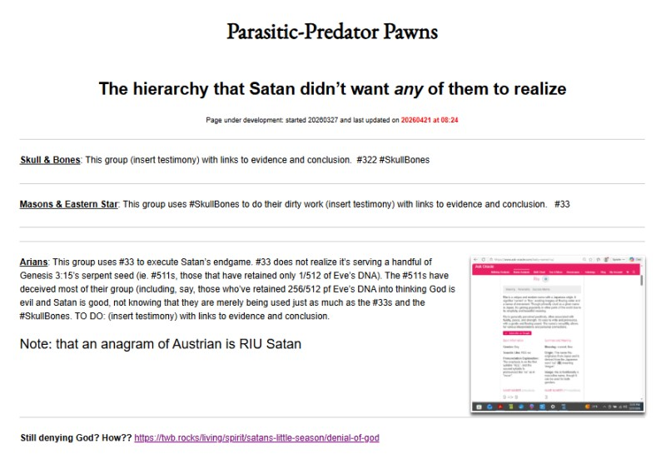
See more evidence being linked to https://twb.rocks/living/spirit/satans-little-season/beast-system/parasitic-predator-pawns as time permits.
033 – Insert title


Theme of Rigorous Themes. Deirdre Moore, devoted mum of court-napped children (Sean Kiska & Cate Kiska) in Canada's capital

