Dear Dr. White,
Re: More TMR/TMU/TMB product suggestions + Warning about 2026 FIFA World Cup & more*
I trust you received my hand-written, 20260425 letter that was included with several non-liquified soap samples and a couple of postcards. Enclosed is the typed version that some of the 52 U.S. Governors also received (see evidence being published at https://twb.rocks/living/opinion/twitter).
Sending to you a prototype of “Meaningful Quest” (“MQ”, style 1^{[1]}) is one reason for this correspondence as Third Man Upholstery (“TMU”) already exists and there could be partnership opportunities. The Bible that I have enclosed this time was not my first choice for MQ. Originally, I was planning to include on that had a slick, faux-leather cover; but, it was a New International Version(“NIV”) which has chosen to delete important verse Matthew 17:21 from its pages. Although the King James Version (“KJV”) is not perfect either—it chose “harmless” over “innocent” for Matthew 10:16—an intentional mistranslation in my opinion^{[2]} (see reasons at https://twb.rocks/living/spirit/satans-little-season/beast-system/malevolent-government/your-choice): His judgment will likely not measure “harm”, but guilt. My preference is the study of multiple Bible versions as they all seem to de-emphasize a key message via sub-optimal language/vocabulary and/or punctuation/grammar choices. MQ, however, is intended to be a mobile Bible-study game. A purse-sized KJV has been my “go-to” while travelling; so, I have included on for you (even though it does not match).
The prototype for “The Chronology Canvas” remains on hold until my Septuagint^{[3]} arrives; however, the concept and some support materials have been pre-published at https://twb.rocks/living/spirit/chronology-canvas. Again, TMU may be in a position to produce this Bible-study aid easily. It could also be an option for inclusion in MQ (like whatever Bible Third Man Books (“TMB”) may choose to offer/include. The wooden blocks, the tooth picks and the cord? I am working on a “Teach Yourself Braille” (“TYB”) necklace, an idea that someone shared several months ago. I still need to secure a drill before starting that prototype but thought I would share the idea^{[4]} now, in case you know of anyone who might be in a position to produce that.
The second reason for writing to you today? My concern that the 2026 FIFA World Cup could be leveraged into some international “super-spreader” event. Please review the materials stored at https://twb.rocks/world-cup ASAP to reach your own conclusions. As multiple U.S. Governors appear to be involved in multiple cover-up operations—not unlike Cabinet Ministers in Canada or Senator Kim Pate (see partial testimony and evidence stored at https://twb.rocks/domestic-terrorism/perpetrators/individuals/kim-pate)—my question now is:
“What won’t they do next?”
during Satan’s “little season” (that is, Revelation 20:9).

Deirdre Moore, CFA, BBA of SAQOTU Inc.
(518) 360-7003
dmoore@twb.rocks || ascjak@outlook.com
P.S. Given the possible severe implications of above, God-willing, multiple versions of this letter (with photos/images) will be published at https://twb.rocks/living/appreciation/artists/jack-white/loving-jack-white/20260525-jack-white so it can be distributed by others via multiple methods including but not limited to BOTG (that is, boots on the ground), regular post (while it stills exists), e-mail and “social media” (for those comfortable with being tracked by TPTB (that is, the powers that be)).
P.P.S. HTML version, etc. of previous 20260425 letter and parcel sent to you is stored at https://twb.rocks/living/appreciation/artists/jack-white/loving-jack-white/20260425-jack-white)
P.P.P.S. This 20260525 letter in HTML began in Seattle, WA on 20260526 at 07:15 and was last revised on 20260526 at 08:46 with other versions published:
- MS Word: (insert link)
- Open Text: (insert link and a link to the software for this office productivity tool that allows word processing without the internet is store at https://twb.rocks/productivity-tools)
- a black & white pdf which produces better copies for printing/mailing is stored at (insert link).
_________________________________________________
Enclosures:
- MQ prototype with 1 marked-up vinyl purse and proposed travel game contents (zippered case containing 8 game pieces, 2 dice & several coloured token options; 1 bound notebook, 1 of 2 TŪL mechanical pencils (eg. one for the [scorekeeper] and one for the roller), the lead refill was not included & neither was an eraser; suggested game cards—How To Play, Categories, MQ Question & Answer Samples, Blank Card Templates
- one large-print KJV Bible
- a current TYB prototype materials: a box of wooden blocks, a container of tooth picks and red & white cord
- a typed version of my previous 20260425 letter to you (which is also stored at https://twb.rocks/living/appreciation/artists/jack-white/loving-jack-white/20260425-jack-white with:
  - 20260222 letter to the dearly deceived re: the “Faith vs Works” Deflection and
  - -
- x
Footnotes
[1] –
[2] –
[3] –
[4] –

Images
Image 001
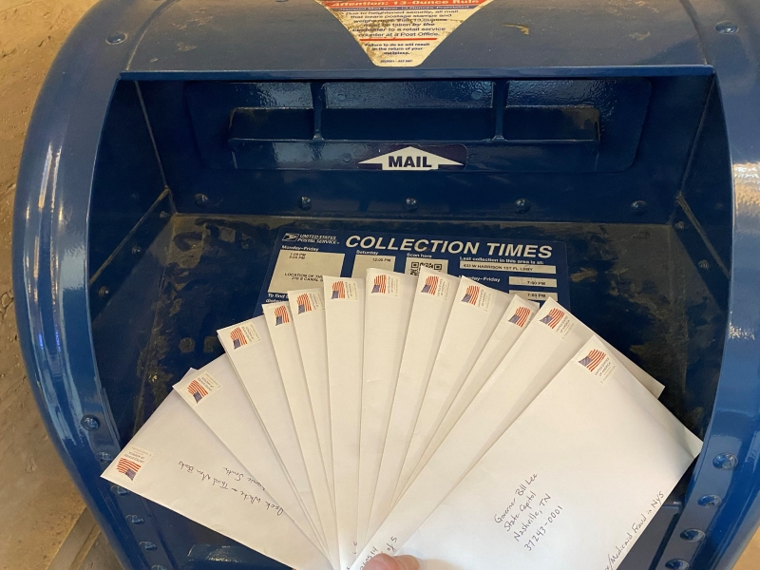
Image 004
Image 007

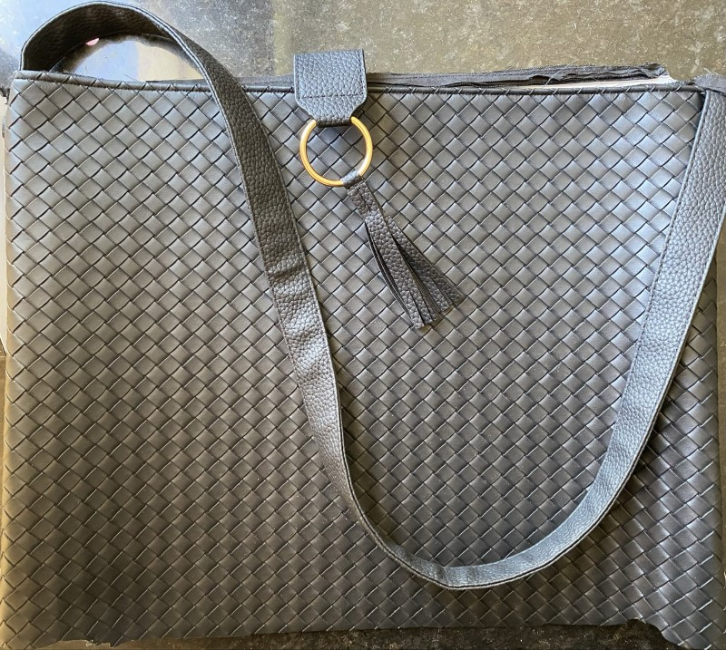
insert comment
002 – insert title
insert comment
003 – insert title
insert comment
004 – insert title
insert comment
005 – insert title
insert comment
006 – insert title
insert comment

