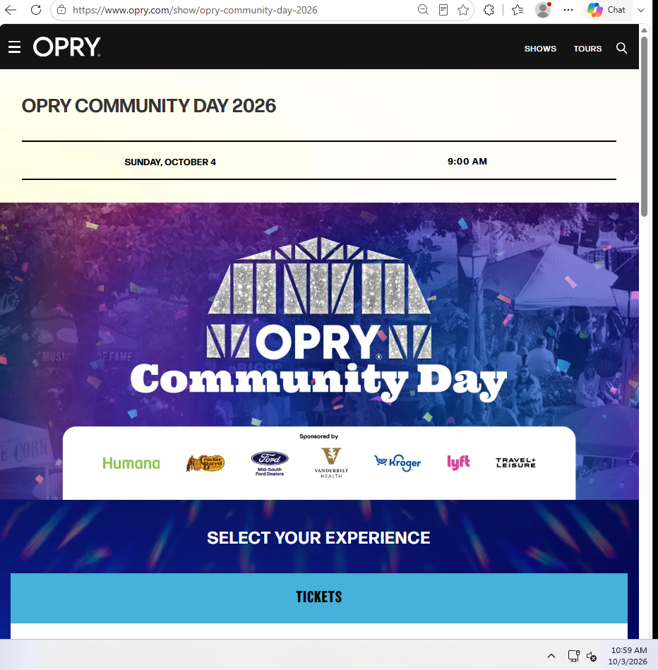
Note: Image is cropped at left to display the word “CORN” and contains multi-coloured, multi-shaped pieces of “confetti”.
From online urban dictionary on 20261003, “corn” is defined as:
- “Bullets or ammunition. Commonly used by London gangs.”
- For example, “load the .44 and crash corn like confetti"
(see https://www.urbandictionary.com)
When review the MSN Newsfeed for 20261003, images included (to do: insert image references in table below).
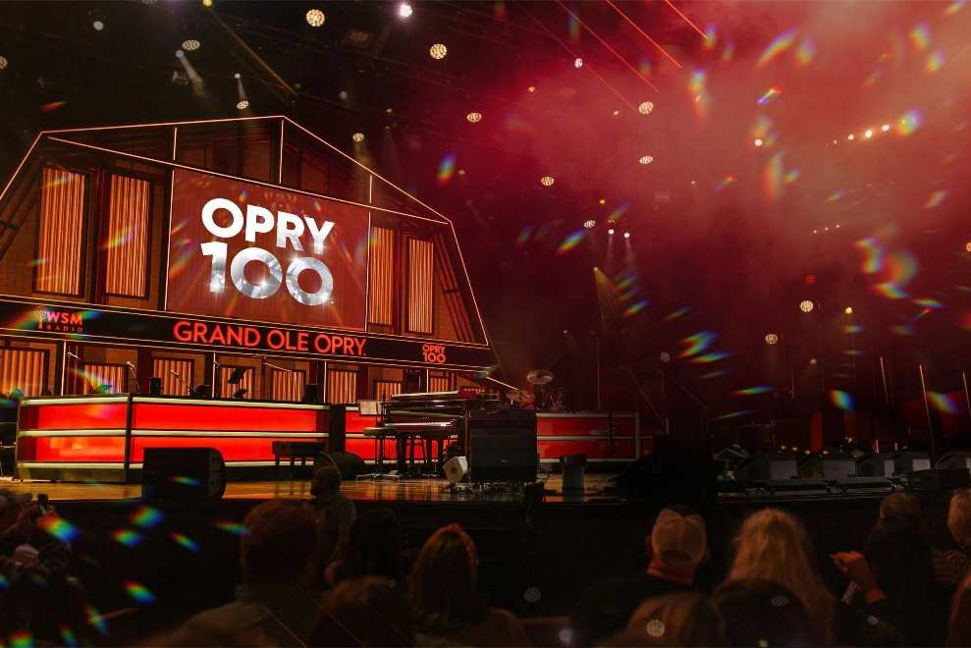
The Grand Ole Opry Birthday Weekend runs October 1-4, 2026, with five (5, V) Opry shows, a Rhett Akins tailgate party, and performances from Vince Gill, The Oak Ridge Boys, Ricky Skaggs, Brandon Lake, and more.
Written by Amanda Tempel > … Temple
Date Published: August 9, 2026 and Last Updated: September 29, 2026
Presented By Humana
Opry Plaza Music Lineup
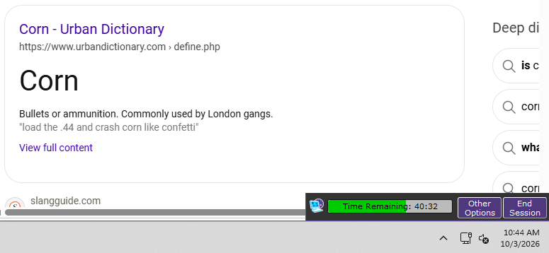
10:00–11:10 a.m. — Mikki Zip (MKKII?)
11:30 a.m.–12:40 p.m. — Brian Sutherland
12:45–1:00 p.m. — Line Dancing with Darcy Lyn
1:00–2:10 p.m. — Jake Hess
2:30–3:40 p.m. — Lost Saints
3:45–4:00 p.m. — Line Dancing with Darcy Lyn
4:00–5:00 p.m. — Alyssa Flaherty
5:10–6:30 p.m. — Aurora Sage

